Introduction to Management Week 6 Study Group Sem 2

# My notes

* Leadership is the process of influencing others to achieve group or organisational goals.

* Leadership traits (trait theory)
  + Effective leaders possess a similar set of traits
  + Traits a stable characteristics such as abilities, psychological motives or consistent patterns of behaviour.
  + Born, not made.
  + Different in the following areas:
    - Drive
    - Desire to lead
    - Honesty/integrity
    - Self-confidence
    - Emotional stability
    - Cognitive ability
    - Knowledge of the business

* Leadership behaviour
  + Initiating structure
    - The degree to which a leader structures the roles of followers by setting goals, giving directions, setting deadlines and assigning tasks
  + Considerations
    - The extent to which a leader is friendly, approachable and supportive and shows concern for employees.
  + University of Michigan:
    - Initiating structure and considerations are on either side of a spectrum.
  + University of Texas
    - Independent of each other, can have both.

* Blake/Mouton leadership grid

9 
from r' ng.ng of 
9 Country club 
Thoughtful 
of V-aople 
mgan.»tion 
atrrosphere and 
9. 9 managment 
V-aople: interdependerwe 
through a stake' 
relatF5_mships of trust 
6, 6 management 
balancing the 
to get morale 
of at • level. 
l, I Impoverished management 
required work done approprMe 
to sustain 
a minimum 

* Contingency theory
  + A leadership theory that states that in order to maximise work group performance, leaders must be matched to the situation that best fits their leadership style.
  + Leaders are effective when their team works well.
  + Leaders are unable to change their leadership style and will be more effective when their styles are matched to the right situation.
  + Effectiveness of a leader depends on the situation permitting the leader to do so.

* Leadership style: least-preferred co-worker
  + Leadership styles are tied to personalities and unconscious needs.
  + LPC is a survey:

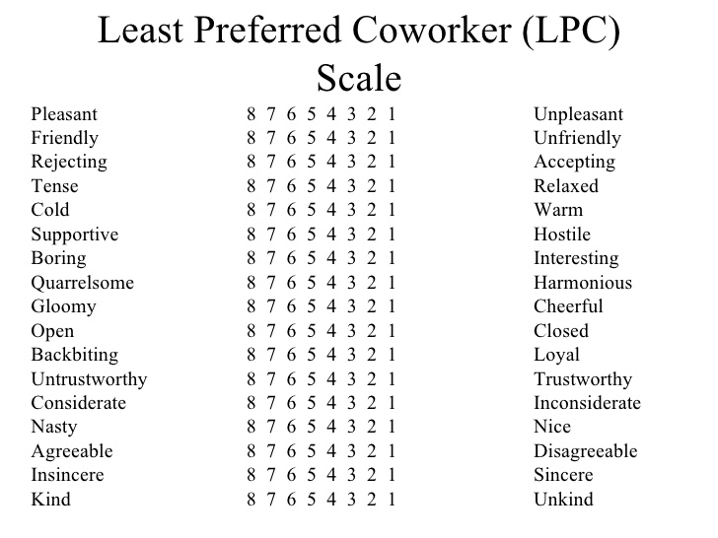

* People who describe the LPC in a more positive way have relationship-oriented leadership styles (64 and above)
  + People oriented.
* People who describe their LPC in a negative way have task-oriented leadership styles (57 and below)
  + Focus on getting the job done.
* People with more moderate scores (58-63)
  + More flexible, not concerned how people see them.

* Situational favourableness
  + The degree to which a particular situation either permits or denies a leader the chance to influence the behaviour of group members.
* Leader-member relations
  + The degree to which followers respect, trust and like their leaders
* Task structure
  + The degree to which the requirements of a subordinate's tasks are clearly specified
* Position power
  + The degree to which leaders are able to hire, fire, reward and punish workers.

* Matching leadership styles to situations

Situational favourableness 
Task structure 
Position power 
Strong 
GOO d 
High 
Weak 
Favourable 
poor 
High 
Strong 
Moderately favourable 
High 
Weak 
POO r 
Weak 
Stru-.g 
Unfavouraöle 

* Those with high LPC scores do better under moderately favourable situations.
* Those with low LPC scores do better in highly favourable situations or situations that are highly unfavourable.
* Those with moderate scores tend to do well in all situations but not as well as leaders who excel in their particular situations.

* Path-goal theory
  + A leadership theory that states that leaders can increase subordinate satisfaction and performance by clarifying, and clearing the paths to goals and by increasing the number and kinds of rewards available for goal attainment.
    - You must be the source of reward.
    - Leader behaviours must offer something unique and valuable to followers beyond what they're already experiencing as they do their jobs or can do for themselves.
    - Leaders **can** change their leadership style.

EnvWonm•nta contingencies 
• Fcrmal authori•.v 
• work 
Path—goal theory 

* Directive leadership
  + Leader lets employees know precisely what is expected of them, gives them specific guidelines for performing tasks, schedules work, sets standards of performance and makes sure that people follow standard rules and regs.
* Supportive leadership
  + Leader is friendly and approachable, shows concern for employees and their welfare, treats them as equals and creates a friendly climate.
* Participative leadership
  + Leader consults employees for their suggestions and input before making decisions.
* Achievement-oriented leadership
  + Leader sets challenging goals, has high expectations of employees and displays confidence that employees will assume responsibility and put in extraordinary effort.

Path—goal theory: when to use directive, supportive, paRicipative or achievement-oriented leadership 
Directive leadership 
Unstructued tasks 
Wcvkers Wit external Itxus Of 
kers 
Workers 
Supportive leadership 
Structured, simple, reFEti%ve tasks 
stressful. frustrating tasks 
Workers lack confidence 
Clear formal authority system 
Workers with high perceived ab,hty 
Participative leadership 
Complex tasks 
Woåers With internal locus Of control 
Experienced workers 
Achievemen t-orie nted 
leadership 
UnchalJe--.g•m tasks 